Mohamed Ahmed ABd El –Hameed El-Melegy
Add. El-Madares St., Sers El-Lian, Menoufia, Egypt
Current add. El-Madres St., Sirs El-Lien, Menoufia, Egypt
Home Tel. : +2 048 3354659
Mobile number: +2 01110722248
Mob what sup.:+201125889517
E-mail : drmohammedpharmacy@yahoo.com
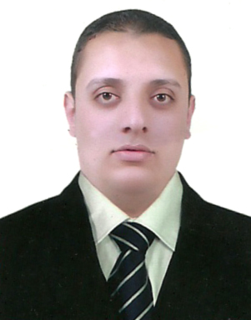
Personal Information:
Date of Birth : 10 June, 1986
Nationality : Egyptian
Governmental Obligations : Not Determined.
Military State : Postponed
Marital State : married
Education:
-Clinical pharmacy oncology diploma 2011
-Professional Accreditation certificate from Saudi Commission for Health specialized at Saudi Arabia of Kingdom, 2010
-B.Sc. of Pharmaceutical Sciences. Faculty of Pharmacy, Tanta University
Grade Good May, 2009
Objectives:

Seeking a job as pharmacist
Where I can apply my academic background, pervious experience and interpersonal skills.
Summer Training:
10 July, 2008 to 25 July, 2008 at Tanta governmental Hospital.
3 August, 2008 to August, 2008 at Sirs El-Lien Governmental Hospital.
June, 2006 to September, 2006 at Nasser Pharmacy
June, 2005 to September, 2005 at Nasser Pharmacy
June, 2004 to September, 2004 at Nasser Pharmacy

Working Experiences:
Working as a community pharmacist under title of “Pharmacy Manager”
At DRMOHAMMED PHARMACY from March 2015 till now.
Working as a community pharmacist under title of “Pharmacy Manager” at DMSCO (Al-Dawaa Medical services Co) Dammam Area from March 2012 till march2015.
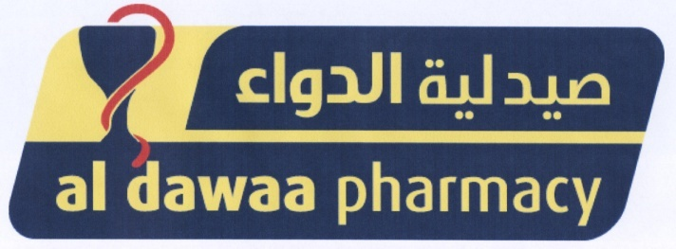
March 2011 to march 2012: working as a community Pharmacist at
Doctor Diaa community pharmacy.
December 2009 to March 2011: working as a community Pharmacist in
Doctor Mohamed Polyclinic at Kingdom of Saudi Arabia.
July 2009 to November 2009: working as a community Pharmacist in
Salah El-Din community Pharmacy.
Courses:
-“Orientation, Scientific & Skills Training Program” hosted by AL_DAWAA Training &Development Department.
-Student's skills developing program (SSDP) certified by RTC (recruitment and Training Committee) hosted by Cairo University.
-November 2008 RTC course of Promotion and sales in Pharmacy College at Cairo University
Languages:
Arabic : Mother tongue
English : Very Good
French : little

Computer Skills:
ICDL course has been taken with grade good.
Microsoft Office (Word and Power Point): Good.
Windows, Internet: Good.

Personal interests:

Football, Tennis, Music& internet browsing.

Personal Skills:
Hard worker, self-motivated and love my work
Ability to work in team work.
High communication skills.
Relevant skills in the Job I hope for it.
Ability to work under pressure, with team work spirit.
Ability to convince others.
Motivator and accurate.
CREATIVE.

Thanks and I hope to join your Team

